Human Population and the Environment:
A Global perspective
Background information
Your Mission:
This assignment can be done in partners or individually. You must create a poster/website/powerpoint creatively illustrating answers to the following questions in 3 categories
- Global population growth
- Local population growth
- Local environmental impacts
Section 1: Global population growth
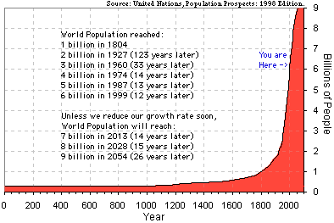
The above chart describes the growth of the human population (we are currently over 7 billion).
- How does the following quote make you feel? Are you concerned? Excited?

It took the human species:
300,000 years to reach the first billion
130 years to add the second billion
30 years to add the third billion
15 years to add the fourth billion
- years to add the fifth AND sixth billion
10 years to add the seventh billion

- Describe the factors that have caused such a dramatic spike in human population over the last hundred years. Describe some of the benefits and challenges associated with this growth.
Next, please select a region/country/city of the world that has experienced significant population growth over the past hundred years.
Section 2: Local population Growth
- Describe the population growth in your selected region in a number of ways.
  - What was the population of your selection around the year 1900?
  - What is the population currently?
  - What is the growth rate?
  - What is driving the population expansion in that region? (additional industries, changing attitudes about sex, etc.)
  - What are the social and economic implications of this growth?
    - Is most of the growth happening amongst the rich/poor/middle class in your region
    - In your opinion is this growth a good thing from the point of view of society and the economy
  - What do you anticipate the population will be in the year 2100? What will be the good and bad things about this?
Section 3: Local Environmental Impacts
- Describe the impacts of human population on the surrounding environment:
  - What was the natural environment like around the year 1900 in terms of its air, soil, and water quality (see if you can find and describe some pictures)?
  - What is the state of the environment currently in terms of air, soil, and water quality (see if you can find and describe some pictures)??
  - List some of the factors creating changes to the quality of the air, soil, and water?
  - Describe specific effects the expanding human population has had on the air soil and water quality
  - Describe specific technologies (ie – water or sewage treatment plants) intended to maintain the state of the environment.

To decide on the city or region, try googling something like “most polluted cities in the world” or “most polluted countries in the world”. Also, consider cities whose pollution you have heard about (Los Angeles smog or radioactive water in Japan)

