Biological indicators
- Create a water quality index for biological indicators using the following table
Analysis
Data Table 2: Calculation of Water Quality Index __________ River, Site ____
Sample | Group 1 | Group 2 | Group 3 | Water Quality Index | Water Quality Rating
 | Number of species x 3 | Number of species x 2 | Number of species x 1 | Sum of groups (1 + 2 + 3)
1
2
3
4
Water Quality Rating: >20 = excellent 16-20 = good 11-15 = fair <11 = poor

- In 100 words, comment on how biological indicators helped you to determine the water quality of our site close to Luther

- In a 200 word conclusion, describe the overall water quality of our Luther water site combining the information from physical, chemical, and biological indicator labs.

Macroinvertebrate Taxa Groups
GROUP 1 (These organisms are generally pollution-intolerant. Their dominance generally signifies GOOD WATER QUALITY.)
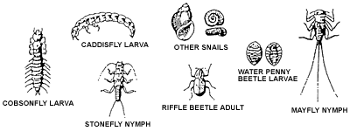

GROUP 2 (These organisms can exist in a wide range of water quality conditions.)
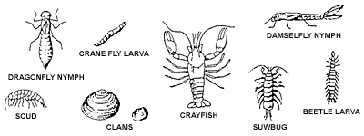

GROUP 3 (These organisms are generally tolerant of pollution. Their dominance usually signifies POOR WATER QUALITY.)
